

Health care system design

RTOS TASK



Youssef Ahmed Abbas mohamed

team 4

# Overview

This is a simple design for a Healthcare system using RTOS (real-time operating system) with the following Requirements.

1. A touch LCD is an input that controls the system and gives commands. Every LCD command is represented in 4 bytes. LCD is connected to the microcontroller through UART with a speed of 9600 bps [Bit per second]. (Reading 4 bytes and processing the command takes 2 ms)
2. Blood pressure sensor with new data every 25ms. (Reading the sensor and processing its data takes 3 ms)
3. Heartbeat detector with new data every 100ms. (Reading the sensor and processing its data takes 1.5 ms)
4. Temperature sensor with new data every 10ms. (Reading the sensor and processing its data takes 2.5 ms)
5. Alert siren. (Activate or deactivate the siren takes 1 ms)

# Goals

* determine how many tasks are needed the system.
* determine the specification of each task (Deadline - periodicity - priority) decide the systick rate
* calculate
  + hyperperiod
  + CPU load
* Draw the timeline manually the expected schedulablility of the system Model the system in Simso

|  |  |  |  |
| --- | --- | --- | --- |
| Task id | Periodicity | Deadline | Priority |
| T1_TLCD | 100 | 100 | 4 |
| T2_BLD_PR | 25 | 25 | 2 |
| T3_HEART_RATE | 100 | 100 | 3 |
| T4_TEMP_SEN | 10 | 10 | 1 |
| T5_ALEART | 10 | 10 | 0 |

# Tasks in system

The following table 1 is shown the tasks with each (Periodicity, Deadline, Priority)

The task with Higher number has higher priority.

Table 1 Tasks Parameters

# System Tick Rate

Systick rate we must calculate the TotalExecutionTime.

TotalExecutionTime = (2+3+1.5+2.5+1) = 10ms

So TotalExecutionTime is 10ms.

# Hyperperiod

Hyperperiod = LCM (tasks periodicity) =LCM (100,25,10) = 100

# CPU Load

|  |  |  |  |
| --- | --- | --- | --- |
| Task id | Periodicity(ms) | Execution Time(ms) | Busy time  (E*(H/P)) |
| T1_TLCD | 100 | 2 | 2 |
| T2_BLD_PR | 25 | 3 | 12 |
| T3_HEART_RATE | 100 | 1.5 | 1.5 |
| T4_TEMP_SEN | 10 | 2.5 | 25 |
| T5_ALEART | 10 | 1 | 10 |
| TOTAL | | | 50.5 ms |

Table 2 task busy time

CPU load = (Total busy time / Hyperperiod) = (50.5 / 100 ) = 0.505 = **5.05%**

# Timeline and Stimulability

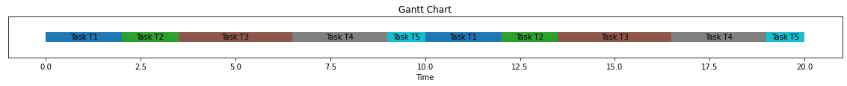

# Simso

